Hadoop Multi-Node Cluster Setup (Hadoop 3.4.0)

Introduction
A Hadoop multi-node cluster allows distributed processing of large datasets by leveraging multiple nodes for storage and computation. This setup ensures high availability, fault tolerance, and parallel execution of tasks.

Step 1: Download and Install Hadoop and Java

Extract Hadoop and Java
Download Hadoop and Java and extract the Hadoop archive using the following command:
tar -zxvf hadoop-3.4.0.tar.gz

Set Java Path in Bash Configuration
Edit the ~/.bashrc file to include the Java path:
nano ~/.bashrc
Add the following lines:
export JAVA_HOME=/home/username/jdk1.8.0_45
export PATH=$HOME/bin:$JAVA_HOME/bin:$PATH
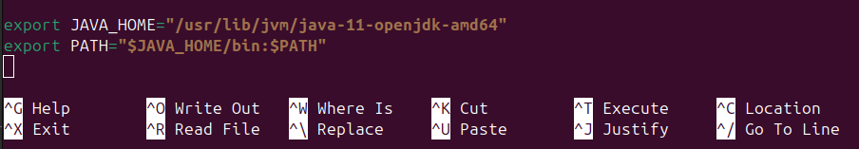
Apply the changes by running:
source ~/.bashrc
Verify the Java installation:
echo $JAVA_HOME
Reason: Setting up the Java path is necessary as Hadoop requires Java to run.

Step 2: Modify Hadoop Configuration Files

Edit Core-Site Configuration (on NameNode)
Modify the core-site.xml file to define the NameNode address:
nano etc/hadoop/core-site.xml
Add:
<property>
<name>fs.defaultFS</name>
<value>hdfs://master:9000</value>
</property>
Reason: This specifies the Hadoop Distributed File System (HDFS) master node.
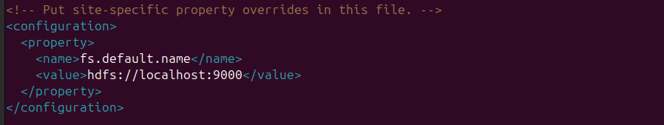

Edit HDFS-Site Configuration (on NameNode and DataNodes)
Modify hdfs-site.xml to define storage directories:
nano etc/hadoop/hdfs-site.xml
Add:
<property>
<name>dfs.namenode.name.dir</name>
<value>file:///home/username/hadoop3-dir/namenode-dir</value>
</property>
<property>
<name>dfs.datanode.data.dir</name>
<value>file:///home/username/hadoop3-dir/datanode-dir</value>
</property>
Reason: These directories store metadata and actual data blocks.

Edit MapReduce Configuration
Modify mapred-site.xml to define the execution framework:
nano etc/hadoop/mapred-site.xml
Add:
<property>
<name>mapreduce.framework.name</name>
<value>yarn</value>
</property>
Reason: YARN (Yet Another Resource Negotiator) is responsible for resource management and job scheduling.

Edit YARN Configuration (on ResourceManager and NodeManagers)
Modify yarn-site.xml to configure YARN services:
nano etc/hadoop/yarn-site.xml
Add:
<property>
<name>yarn.nodemanager.aux-services</name>
<value>mapreduce_shuffle</value>
</property>
<property>
<name>yarn.resourcemanager.hostname</name>
<value>master</value>
</property>
Reason: This ensures that the ResourceManager handles job execution.

Configure Hadoop Environment Variables
Edit hadoop-env.sh to set Java path:
nano etc/hadoop/hadoop-env.sh
Modify the following line:
export JAVA_HOME=/home/username/jdk1.8.0_45
Repeat the same for mapred-env.sh and yarn-env.sh.

Configure Workers File (on Master)
Define the worker nodes in workers file:
nano etc/hadoop/workers
Add:
slave1
slave2
Reason: This file lists the nodes participating in the cluster.

Step 3: Set Up SSH for Passwordless Login
Install SSH server:
sudo apt-get install openssh-server
Generate an SSH key pair:
ssh-keygen -t rsa
Copy the public key to worker nodes:
ssh-copy-id -i ~/.ssh/id_rsa.pub username@slave1
ssh-copy-id -i ~/.ssh/id_rsa.pub username@slave2
Verify SSH access:
ssh slave1
ssh slave2
Reason: Passwordless SSH is required for seamless communication between nodes.

Step 4: Format the NameNode
Before starting Hadoop, format the NameNode:
hdfs namenode -format
Reason: This initializes the Hadoop filesystem structure.

Step 5: Start Hadoop Services
Run the following commands to start Hadoop:
sbin/start-dfs.sh
sbin/start-yarn.sh
Verify service status:
- NameNode Web UI: http://master:9870/
Reason: These commands start HDFS and YARN services.

Step 6: Stop Hadoop Services
To stop all Hadoop services, run:
sbin/stop-all.sh
Reason: This gracefully shuts down all Hadoop processes.

Cluster Roles and Responsibilities

Processes Running on the Master Node:
- NameNode (HDFS): Manages file system metadata.
- Secondary NameNode (HDFS): Periodically checkpoints metadata (not a failover node).
- ResourceManager (YARN): Allocates cluster resources.

Processes Running on Each Worker Node:
- DataNode (HDFS): Stores actual data blocks.
- NodeManager (YARN): Runs tasks on worker nodes.

Some of the differences between Single-Node and Multi-Node Hadoop Cluster Setup
- Core-Site Configuration
  - Single-Node Setup: Uses hdfs://localhost:9000 since all Hadoop services run on the same machine.
  - Multi-Node Setup: Uses hdfs://master:9000 where master is the NameNode’s hostname. This allows all Worker nodes to communicate with the NameNode.
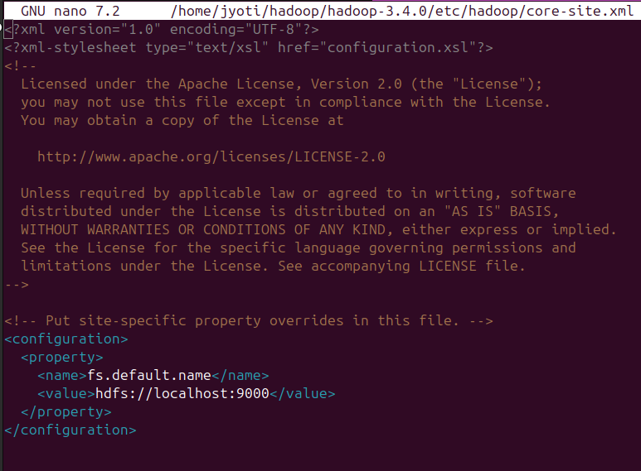
- SSH Configuration
  - Single-Node Setup: No need to copy SSH keys, as all services run on a single machine. Local SSH setup (ssh localhost) is sufficient.
  - Multi-Node Setup: Requires setting up passwordless SSH between the Master and Worker nodes (ssh-copy-id). This allows the Master to start daemons on Worker nodes remotely.

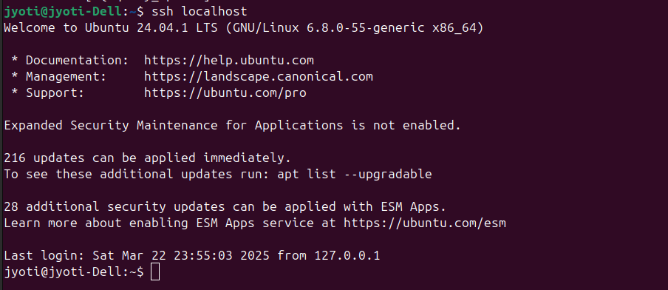
- Workers File (etc/hadoop/workers)
  - Single-Node Setup: Not required, as all components (NameNode, DataNode, ResourceManager, and NodeManager) run on the same system.
  - Multi-Node Setup: Required to specify the hostnames/IPs of Worker nodes (e.g., slave1, slave2). This allows Hadoop to distribute tasks across multiple machines.
- HDFS DataNode Configuration (hdfs-site.xml)
  - Single-Node Setup: The machine runs both the NameNode (managing metadata) and DataNode (storing actual data).
  - Multi-Node Setup: The NameNode runs on the Master node, while DataNodes run on separate Worker nodes to store distributed data blocks.
- YARN Configuration (yarn-site.xml)
  - Single-Node Setup: Both ResourceManager (scheduling jobs) and NodeManager (running tasks) operate on the same system.
  - Multi-Node Setup: The ResourceManager runs on the Master node, and NodeManagers operate on Worker nodes to execute tasks in parallel.
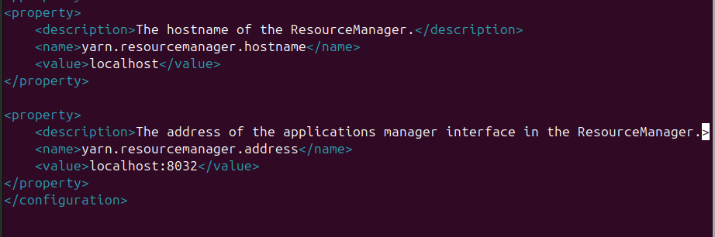
- HDFS Replication Factor (hdfs-site.xml)
  - Single-Node Setup: Typically set to 1 (<value>1</value>) since there is only one machine and no data redundancy is needed.
  - Multi-Node Setup: Set to 2 or more to ensure fault tolerance in case of node failures, improving data reliability.
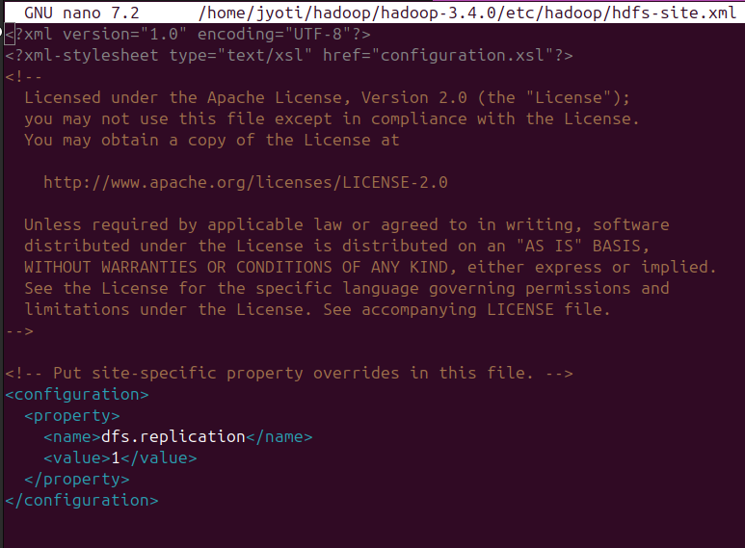

References
https://hadoop.apache.org/docs/stable/hadoop-project-dist/hadoop-common/SingleCluster.html
https://www.michael-noll.com/tutorials/running-hadoop-on-ubuntu-linux-multi-node-cluster/
https://www.michael-noll.com/tutorials/running-hadoop-on-ubuntu-linux-single-node-cluster/

